Loan Risk & Approval Analysis
Loan Risk & Approval Analysis Dashboard
Loan application performance, credit risk and approval insights | 2023–2025
Tools: Python • Pandas • MySQL • Power BI • DAX

Table of Contents
1. Business Problem
2. Project Objectives
3. Dataset Overview
4. Data Cleaning & Preparation
5. SQL Analysis
6. Power BI Dashboard
7. Key Business Insights
8. Business Recommendations
9. Conclusion
10. Tools & Technologies
11. Project Deliverables
12. Power BI Dashboard Preview

1. Business Problem
A lending company receives a large number of loan applications and needs to understand the factors associated with loan approval and rejection. The business wants to analyze approval patterns across employment type, income, loan amount, DTI, credit score, and previous default history. It also needs to monitor application and approval trends over time. The goal is to identify high-risk and lower-approval segments and provide data-driven insights that can support better loan approval and risk assessment decisions.

2. Project Objectives
- Analyze loan application approval and rejection patterns.
- Calculate the overall loan approval rate.
- Analyze approval rates across different employment types.
- Understand the relationship between income level, loan amount, and loan applications.
- Analyze the relationship between DTI (Debt-to-Income Ratio) and loan approval.
- Compare approval rates for customers with and without previous default history.
- Analyze monthly loan application and approval trends over the available period.
- Build an interactive Power BI dashboard to present key insights and support data-driven lending decisions.

3. Dataset Overview
• Total Records: 50,000
• Time Period: 2023–2025
• Domain: Banking / Lending / Credit Risk
• Target/Outcome: Loan Approval / Rejection
• Data Analysis Tools: Python, SQL, Power BI
This project uses a loan application dataset containing 50,000 records covering the period from 2023 to 2025. The dataset contains customer financial, credit, employment, and loan-related information. The analysis focuses on understanding loan approval and rejection patterns and identifying factors associated with loan approval.

4. Data Cleaning & Preparation
The loan application dataset was cleaned and prepared using Python and Pandas before performing SQL analysis and building the Power BI dashboard. Data types were checked to ensure that numerical, categorical, and date fields were correctly formatted. Relevant fields were reviewed for consistency, and additional categories such as income groups and DTI categories were created for analysis. The prepared dataset was then used for SQL-based analysis and Power BI visualization.
- Checked and validated data types.
- Reviewed data fields for consistency and analysis readiness.
- Created income groups using quartile-based categorization.
- Created DTI categories: Low DTI, Medium DTI, and High DTI.
- Prepared Application Date for monthly trend analysis and created a Month Year field for chronological reporting.
- Saved the prepared dataset as loan_risk_cleaned.csv.
- Loaded the prepared data into MySQL and Power BI for analysis.

5. SQL Analysis
SQL was used to analyze loan application performance and identify patterns in loan approval and rejection outcomes. Various aggregation, grouping, filtering, and calculated metrics were used to evaluate customer segments and key financial risk factors.
- Analyzed total loan applications, approved loans, rejected loans, and overall approval rate.
- Compared loan approval rates across different employment types.
- Analyzed income categories and their relationship with loan approval and loan amounts.
- Evaluated approval rates across different DTI categories.
- Compared approval rates between customers with and without previous default history.
- Analyzed monthly loan applications and approval trends.

Key SQL Findings
Analysis | Approval Rate
Low DTI | 62.70%
Medium DTI | 60.31%
High DTI | 59.01%
No Previous Default | 62.19%
Previous Default | 57.69%

6. Power BI Dashboard
An interactive Power BI dashboard was developed to monitor loan application performance and analyze approval and rejection patterns. The dashboard provides a consolidated view of key performance indicators and allows users to explore loan applications across different customer and risk segments.
- KPI Cards: Total Applications, Approved Loans, Rejected Loans, and Approval Rate.
- Slicers: Application Year, Employment Type, and Loan Status.
- Loan Approval vs Rejection: compares approved and rejected loan applications.
- Credit Score vs Approval Rate: compares approval rates across credit score categories.
- DTI Category vs Approval Rate: compares approval rates across DTI categories.
- Average Loan Amount by Income Category: compares average loan amounts across income groups.
- Monthly Loan Applications Trend: shows application volume over time.
- Previous Default vs Approval Rate: compares approval rates based on previous default history.
Tool Used: Power BI

7. Key Business Insights
- The overall loan approval rate is approximately 61.77%, meaning around three out of every five applications were approved.
- Lower DTI categories show higher approval rates than higher DTI categories.
- Customers with no previous default history have a higher approval rate (62.19%) than customers with previous defaults (57.69%).
- Credit score categories show meaningful differences in approval rates, with Good at 64.25%, Average at 60.45%, and Poor at 56.73%.
- Employment type shows relatively similar approval rates across the major employment categories.
- Loan amount varies substantially across income categories, with the Very High Income group showing the highest average loan amount.
- Monthly loan application volume shows fluctuations over time, making trend monitoring useful for lending operations.

8. Business Recommendations
- Give additional attention to applicants with high DTI, as higher DTI is associated with a lower approval rate.
- Consider previous default history as an important risk indicator during loan evaluation.
- Use credit score, DTI, income, and previous default history together rather than relying on a single factor for credit risk assessment.
- Monitor loan application and approval trends regularly to identify changes in customer behavior and approval patterns.
- Develop targeted risk assessment strategies for customer segments with comparatively lower approval rates.
- Use the Power BI dashboard for regular monitoring and data-driven decision-making by lending and risk management teams.

9. Conclusion
This project provided a comprehensive analysis of loan application and approval patterns using Python, SQL, and Power BI. The analysis helped identify relationships between loan approval and factors such as credit score, DTI, income, employment type, and previous default history. The interactive Power BI dashboard brings these insights together and enables users to explore loan performance across different segments. Overall, the project demonstrates how data analytics can support better credit risk assessment and data-driven loan approval decisions.

10. Tools & Technologies
- Python — data preparation and analysis
- Pandas — data manipulation and transformation
- MySQL — SQL-based analysis and aggregation
- Power BI — interactive dashboard development and visualization
- DAX — measures and calculated metrics in Power BI

11. Project Deliverables
- Cleaned Dataset: loan_risk_cleaned.csv
- Python Analysis: Google Colab containing data preparation and analysis
- SQL Analysis: MySQL queries used for loan risk and approval analysis
- Power BI Dashboard: Loan_Risk_Analysis_Dashboard.pbix
- Project Documentation: Detailed documentation of the project, analysis, insights, and recommendations

12. Power BI Dashboard Preview
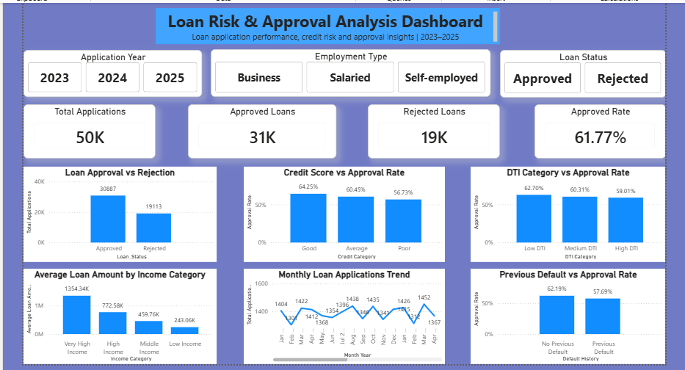
Figure 1: Loan Risk & Approval Analysis Dashboard

